

**Depression Screening System**

|  |
| --- |
|  |

**User’s Manual**

**REQUIREMENTS:**

**RECOMMENDED BROWSERS**

Depression Screening system supports the following Web Browser:

* Google Chrome Version 64 and above

**SYSTEM OVERVIEW**

Our Depression Screening system is a healthcare information & decision system that uses readily available low-cost technology to provide a fully automated, widely accessible, and confidential method of community-wide screening for depression, a common mental illness.

The system employs machine reasoning to prioritize depression screening for segments of the Singaporean adult population most at-risk of experiencing depression by asking users to answer a series of question on their characteristics such as age and race.

At-risk users are guided by the system to self-report whether they had symptoms of depression and the severity of these symptoms. Doctors use these symptoms as criteria to diagnose depression. The system then processes the information with the same expertise as doctors to generate a diagnosis of depression and recommended treatment for the user.

**USER INTERFACE**

Our user interface runs in Java web. Once our inference engine outputs the results, it will display the results onto the web interface.

**DEPLOYMENT**

Our application can run in both Windows and Linux, and in KIE platform.

For KIE platform

Project File

* Download the project zip file /SystemCodes/PHQ9FINAL.zip from GitHub at https://github.com/francis-han/Group-Project.
* It is best to run the project on JBPM 7.16, the link is /Miscellaneous/LINK_yo_JBPM7_16.

Deployment

* In KIE, create a space “PHQ9_FINAL”.
* Import the project into the space created.
* Deploy the project.

Process Flow

* Create user Patient1 and assign the user to Group (kie-server) and to Role (process-admin, admin, analyst, user), create password as Patient1.
* To examine the system, login as Patient1.
* Go to *Process Instances*, create a new process instance.
* Submit the process form without entering any information.
* Go to *Task Inbox*, you will find that Patient1 has receives a task.
* Key in the patient details accordingly to perform risk profiling.
  + If Patient1 is low-risk, then a message will be displayed and the process ends.
  + If Patient1 is high-risk, then another task will be triggered for Patient1.
* Patient1 answers Patient Health Questionnaire-2 (PHQ-2).
  + If Patient1 did not meet the criteria of PHQ-2, then a message will be displayed and the process ends.
  + Otherwise, then another task will be triggered for Patient1.
* Patient1 answers PHQ-2.
  + If Patient1 did not meet the criteria of PHQ-9, then a message will be displayed and the process ends.
  + Otherwise, PHQ-9 score, diagnosis and recommended treatment are displayed and the process ends.

For standalone application – Programme Flow

In order to run the system, you need Java 8 or later versions to be installed.

To run our system, type the command “java -jar mr-phq9-0.1.0.jar”.

Open your preferred browser and go to the URL “http://localhost:8090/” as shown below:

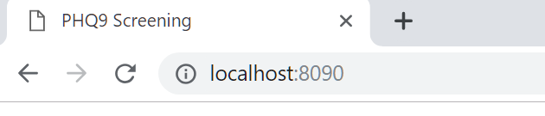

We will be using Google Chrome version 72 (64-bit).

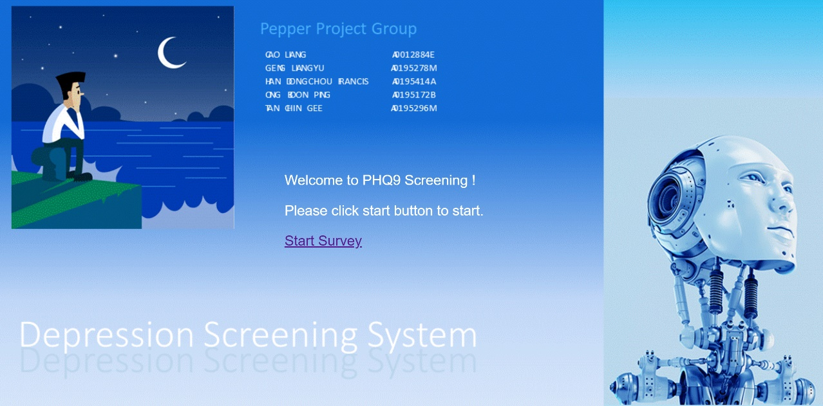

Click on the START SURVEY button. This will lead to the risk profiling session where users answer questions on their demographic characteristics.

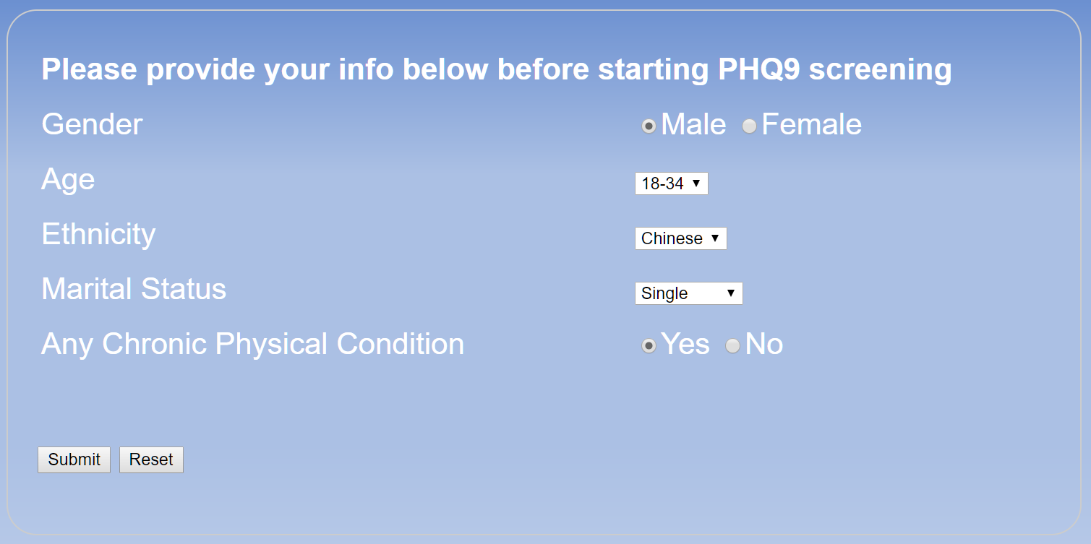

The system determines whether users have a high-risk of experiencing depression based on their demographic profiles, and then directs users to the next step:

* Low-risk users are directed to the exit page, and
* High-risk users are directed to the PHQ-2 page

Low-risk users: The system will display the page below, and then ends the session.

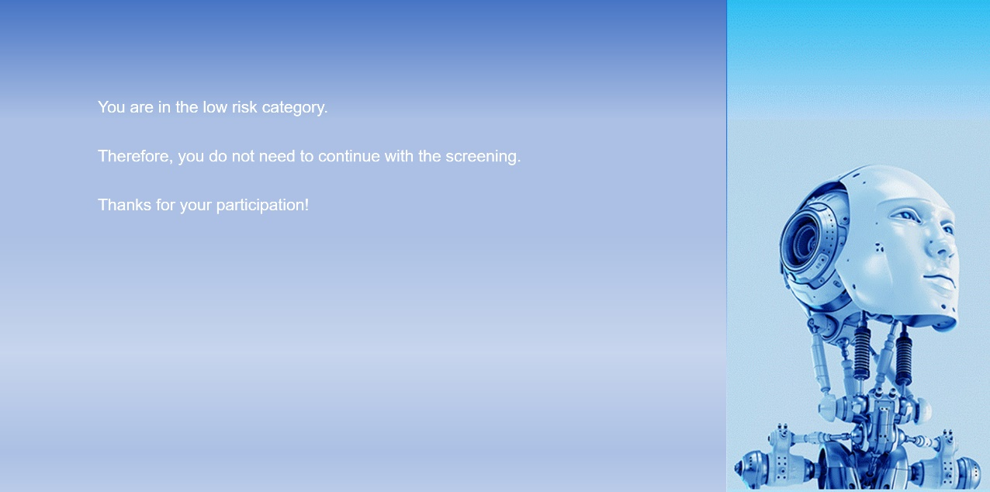

High-risk users: The system will start the PHQ-2 session and asks users to self-report whether they had experienced two symptoms of depression (1. depressed mood & 2. loss of interest or pleasure) and the severity of the symptoms. Below is the page for one of the questions.

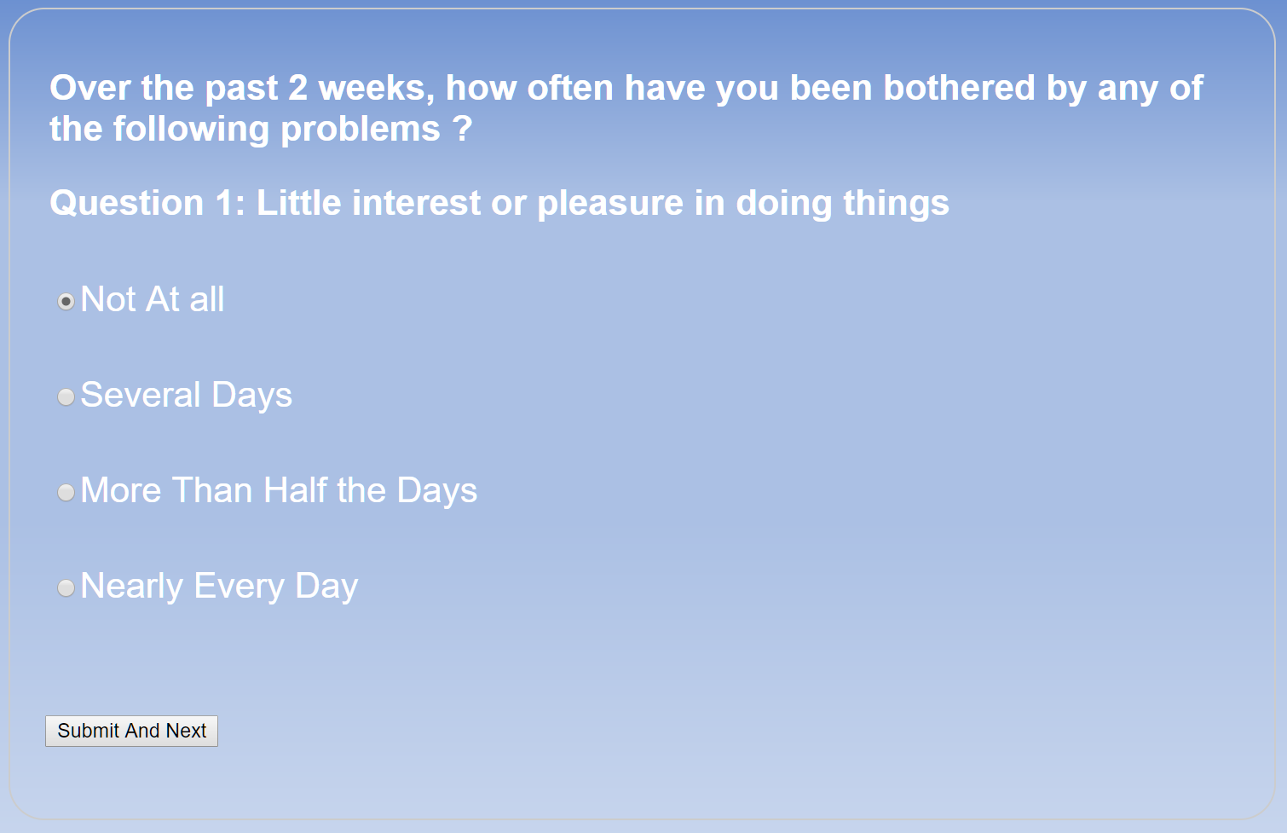

The system determines whether users meet the first criterion for a diagnosis of depression.

1. Users must have reported experiencing either (1) depressed mood or (2) loss of interest or pleasure for at least more than half the days in the past two weeks.

* Users who did not meet the first criterion are directed to the exit page, and
* Users who meet the first criterion are directed to the PHQ-9 page

Users who did not meet the first criterion: The system will display the page below, and then ends the session.

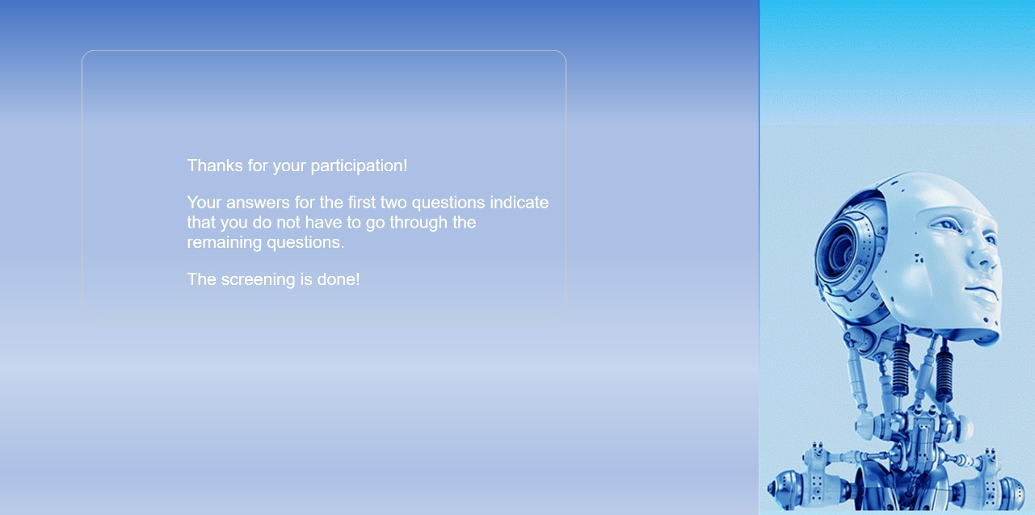

Users who meet the first criterion: The system will start the PHQ-9 session and asks users to self-report whether they had experienced seven additional symptoms of depression and the severity of the symptoms. Below is the page for one of the questions.

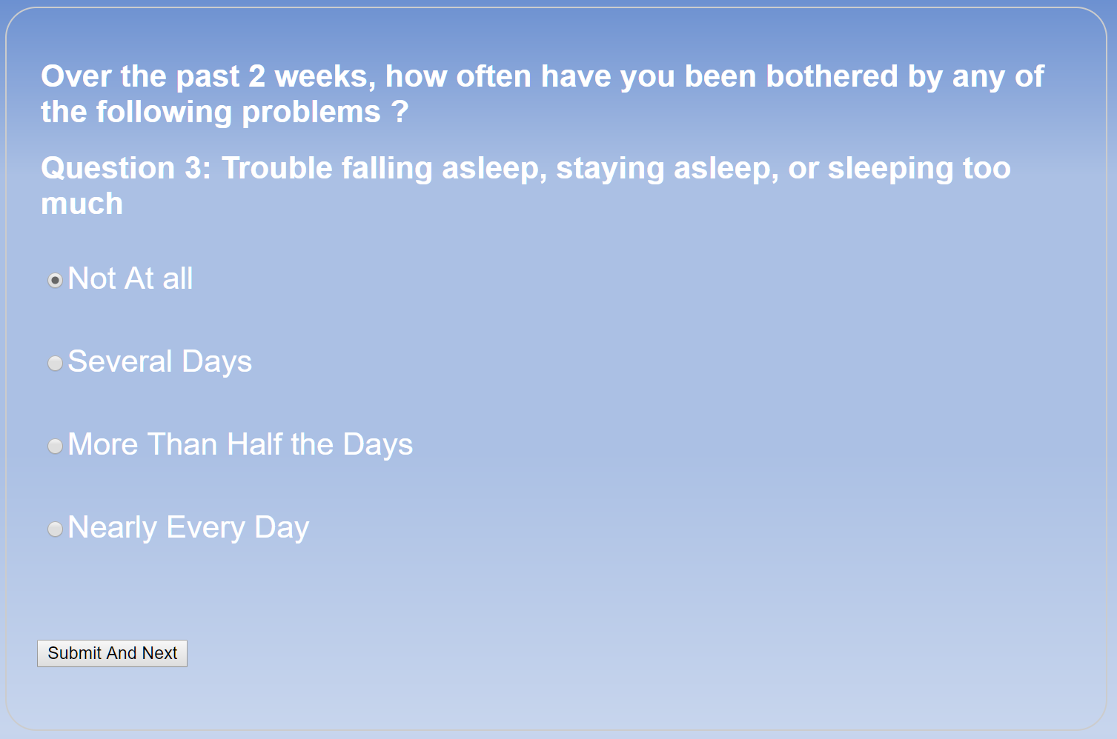

The system determines whether users meet the second criterion for a diagnosis of depression.

1. Users must have reported experiencing five or more symptoms for at least more than half the days in the past two weeks. But the suicide item is counted if users reported experiencing it at least several days in the past two weeks.

* Users who did not meet the second criterion are directed to the exit page, and
* Users who meet the second criterion are directed to the PHQ-9 scores, diagnosis, and recommended treatment page

Users who did not meet the second criterion: The system will display the page below, and then ends the session.

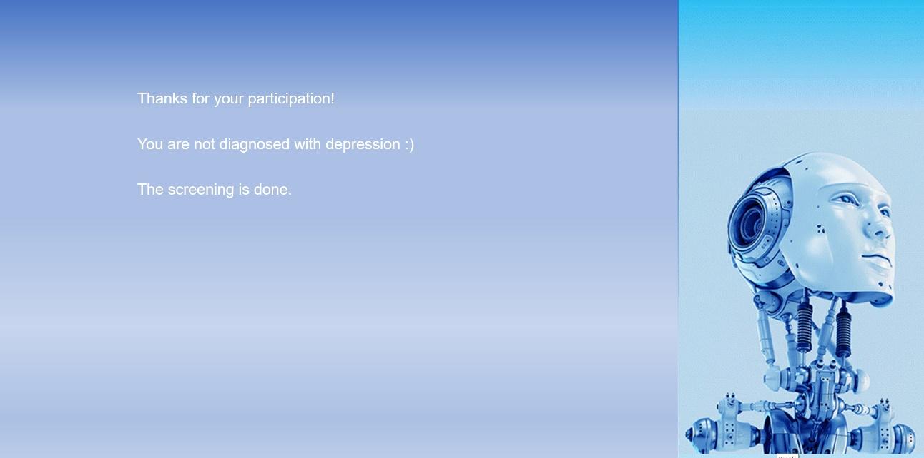

Users who meet the second criterion: The system will display the page showing the PHQ-9 scores, diagnosis and recommended treatment, and then ends the session.

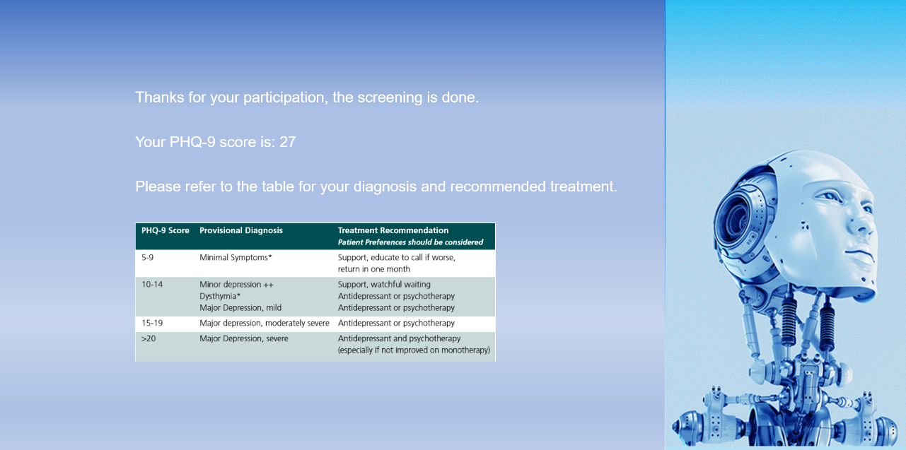

At the end of the screening process, our system will sent a notification to Dr Hong (an assigned practitioner) to review the PHQ-9 score for users.